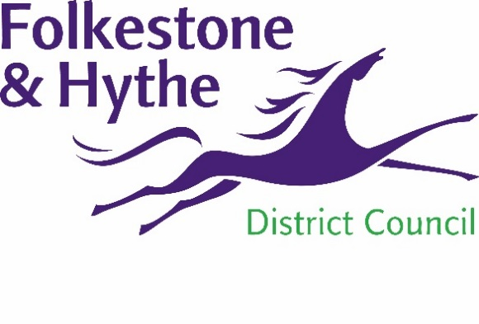
NEWS RELEASE

22 June 2020

JUDICIAL REVIEW CASE DISMISSED BY HIGH COURT

A judicial review into the granting of planning permission for the Princes Parade development has been dismissed by the High Court.
Cllr David Monk, the Leader of Folkestone & Hythe District Council, said: "We welcome the High Court's ruling which shows our planning officers not only followed the appropriate processes, but also made sound recommendations to councillors.
"Applications are always considered thoroughly before a decision is reached, so it is disappointing the professionalism of the team continues to be thrown into question.
"We are aware the claimant may decide to appeal the outcome and – if that turns out to be the case – it is our intention to defend our long-standing position."
The judge who dismissed the High Court case has also ordered the claimant to pay £5,000 in costs to the council.

ENDS

Notes to Editors:

For more information, please email communications@folkestone-hythe.gov.uk

Follow us on Facebook: @FolkestoneandHytheDC
Follow us on Twitter: @fstonehythedc
Follow us on Instagram: @folkestonehythedc
Follow us on LinkedIn: Folkestone & Hythe District Council

